Experiment No.: 4
Experiment No. 5: Shopping Cart System with Array Manipulation, Object Properties and Discount Calculation
- Software/Tools Required: VS Code, Web Browser, HTML, CSS, and JavaScript
- Theory: Arrays in JavaScript provide powerful methods for storing and processing lists of data, while objects allow structured representation of entities with multiple attributes. In a shopping cart, each item can be represented as an object containing properties like name, price, and quantity, and all such objects can be stored in an array. Discount logic is applied by checking conditions such as cart value thresholds or special coupon codes before computing the final bill.

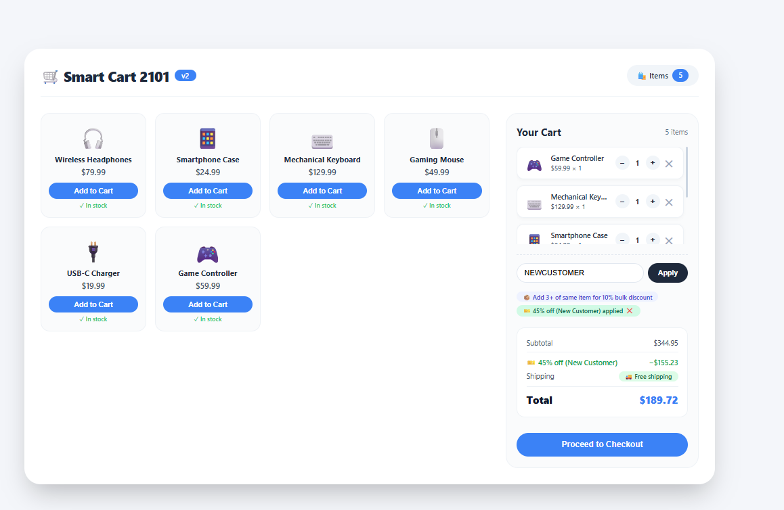

Result: The cart total calculator was successfully implemented using HTML, CSS, and JavaScript. The program stored cart items as objects inside an array and used array methods like reduce() to calculate the total price and map() to display item details. Discount logic was applied using conditional statements, where a 10% discount was given if the total exceeded ₹500. The program correctly displayed the subtotal, discount amount, and final payable amount.
Conclusion: This experiment demonstrates the practical use of JavaScript array methods and object handling in building a real-world application. By creating the cart total calculator, methods such as push(), map(), filter(), and reduce() were clearly understood. Object handling helped in managing product details efficiently, while conditional discount logic showed how business rules can be implemented programmatically. Overall, the experiment provided hands-on experience in applying array and object concepts in a web-based e-commerce style application.

